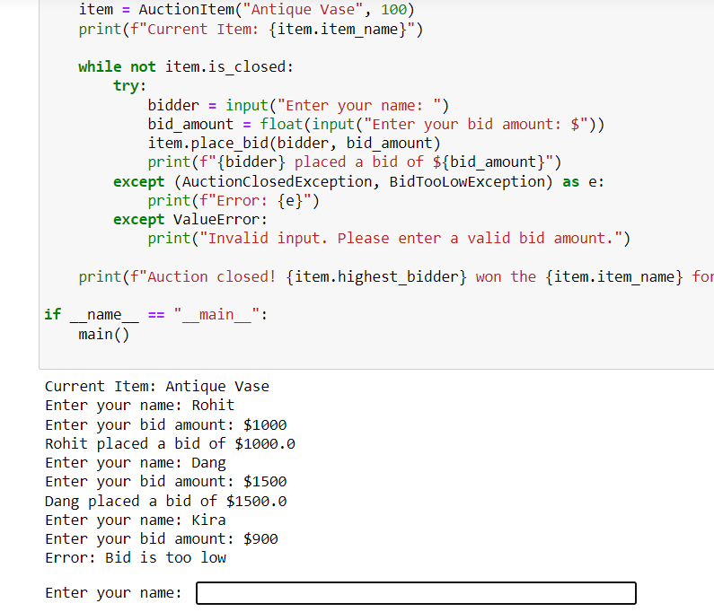

**CODE**

class AuctionItem:

def __init__(self, item_name, initial_price):

self.item_name = item_name

self.current_price = initial_price

self.highest_bidder = None

self.is_closed = False

def place_bid(self, bidder, bid_amount):

if self.is_closed:

raise AuctionClosedException("Auction is closed")

if bid_amount <= self.current_price:

raise BidTooLowException("Bid is too low")

self.current_price = bid_amount

self.highest_bidder = bidder

def close_auction(self):

self.is_closed = True

class AuctionClosedException(Exception):

pass

class BidTooLowException(Exception):

pass

def main():

item = AuctionItem("Antique Vase", 100)

print(f"Current Item: {item.item_name}")

while not item.is_closed:

try:

bidder = input("Enter your name: ")

bid_amount = float(input("Enter your bid amount: $"))

item.place_bid(bidder, bid_amount)

print(f"{bidder} placed a bid of ${bid_amount}")

except (AuctionClosedException, BidTooLowException) as e:

print(f"Error: {e}")

except ValueError:

print("Invalid input. Please enter a valid bid amount.")

print(f"Auction closed! {item.highest_bidder} won the {item.item_name} for ${item.current_price}")

if __name__ == "__main__":

main()